## **Deployment Troubleshooting**

App/hello-world

- Issues app is unreachable via its endpoint.

* Troubleshooting steps
* kubectl get po --namespace udacity
* >>>> hello-world-d696c5567-v2lbg 0/1 CrashLoopBackOff 7 13m
* kubectl describe po hello-world-d696c5567-v2lbg --namespace udacity
* >>>Liveness probe failed: HTTP probe failed with statuscode: 500

Resolving

* Increasing the initialDelaySeconds: to 30
* Increase the periodSeconds: to 20

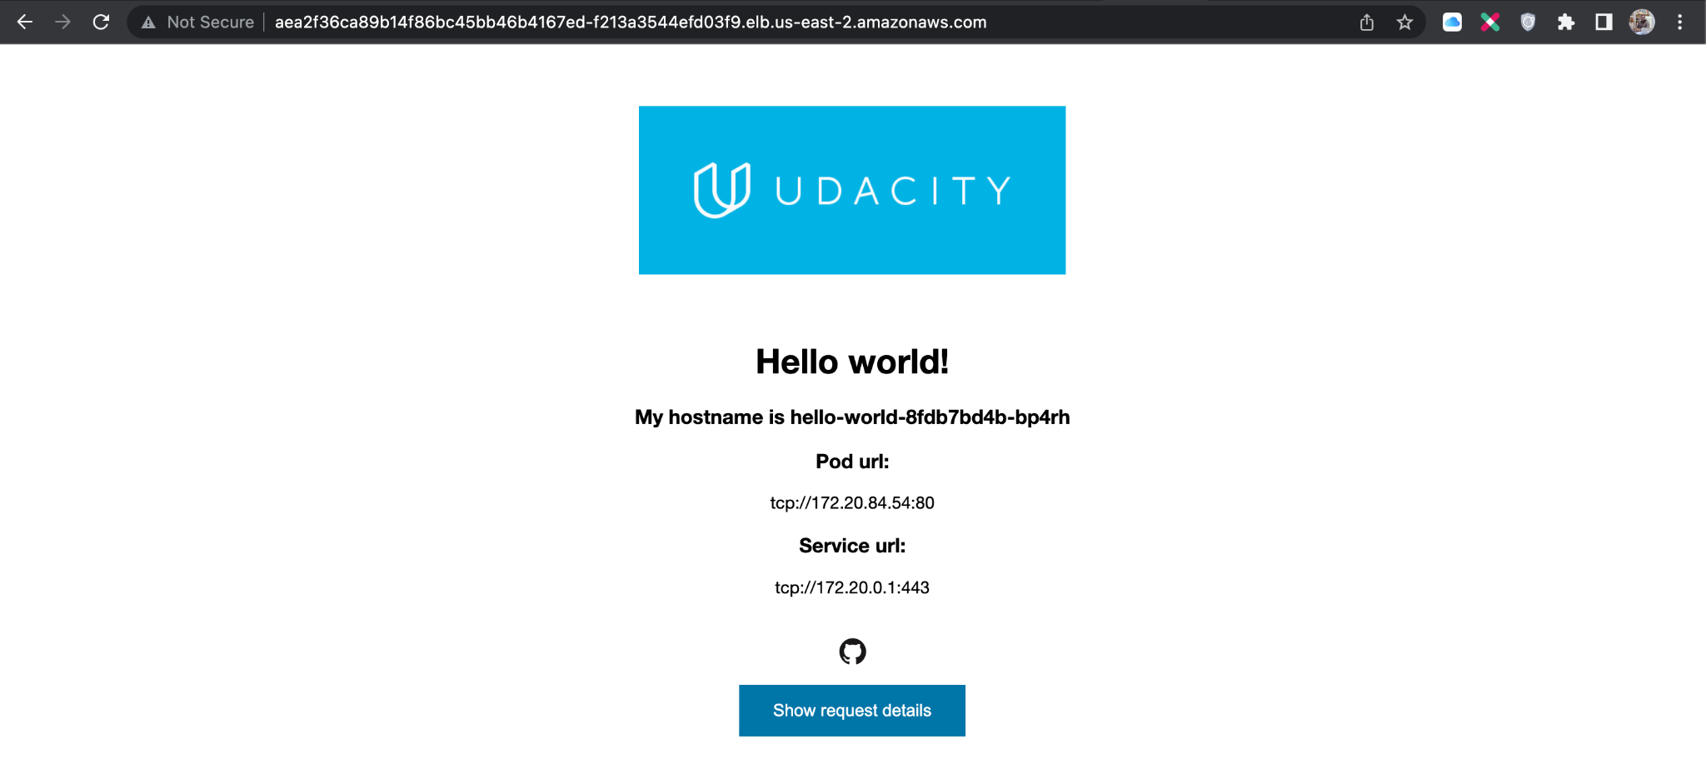

## **Canary Deployments**

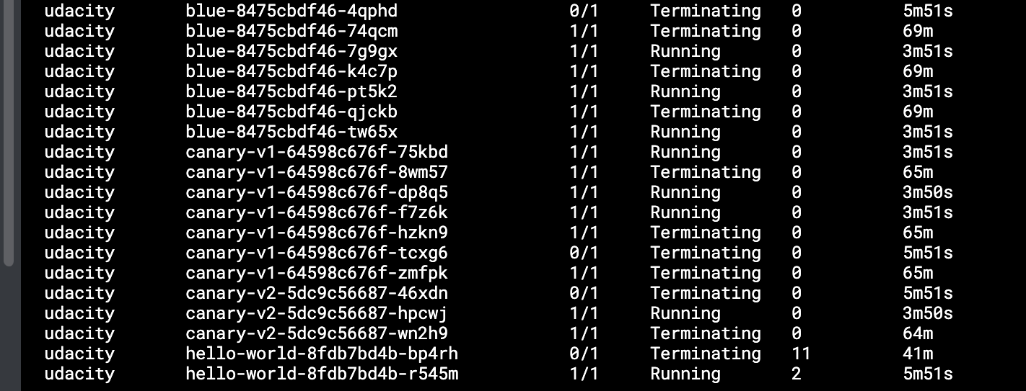

## **Step 4: Node Elasticity**

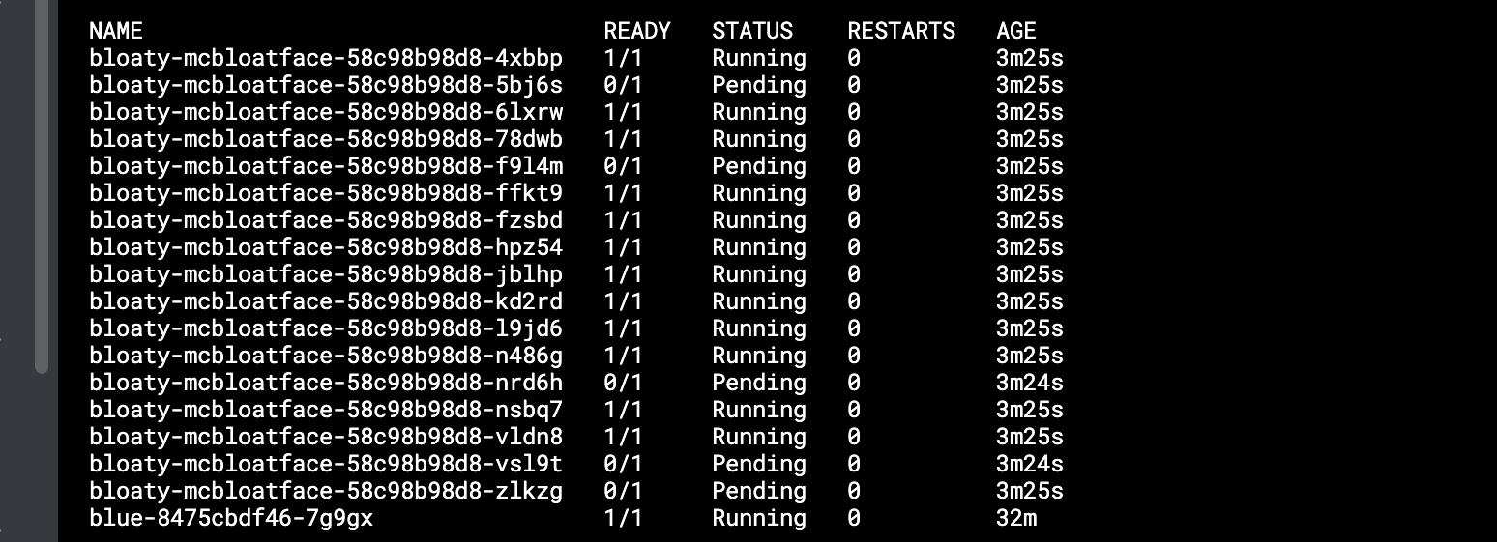

Failed pods

**0/2 nodes are available: 1 Insufficient cpu, 1 Too many pods.**

### **Step 5: Observability with Metrics**

**kubectl top pods --use-protocol-buffers --namespace udacity**

